REST - Country Web Service

Write a REST service that returns India country details in the earlier created spring learn application.

URL: /country
Controller: com.cognizant.spring-learn.controller.CountryController
Method Annotation: @RequestMapping
Method Name: getCountryIndia()
Method Implementation: Load India bean from spring xml configuration and return
Sample Request: http://localhost:8083/country
Sample Response:
{
"code": "IN",
"name": "India"
}
SpringLearnApplication.java:
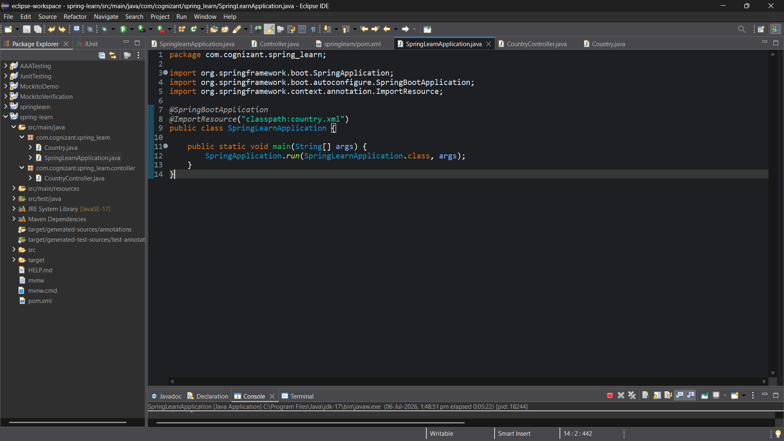

CountryController.java:
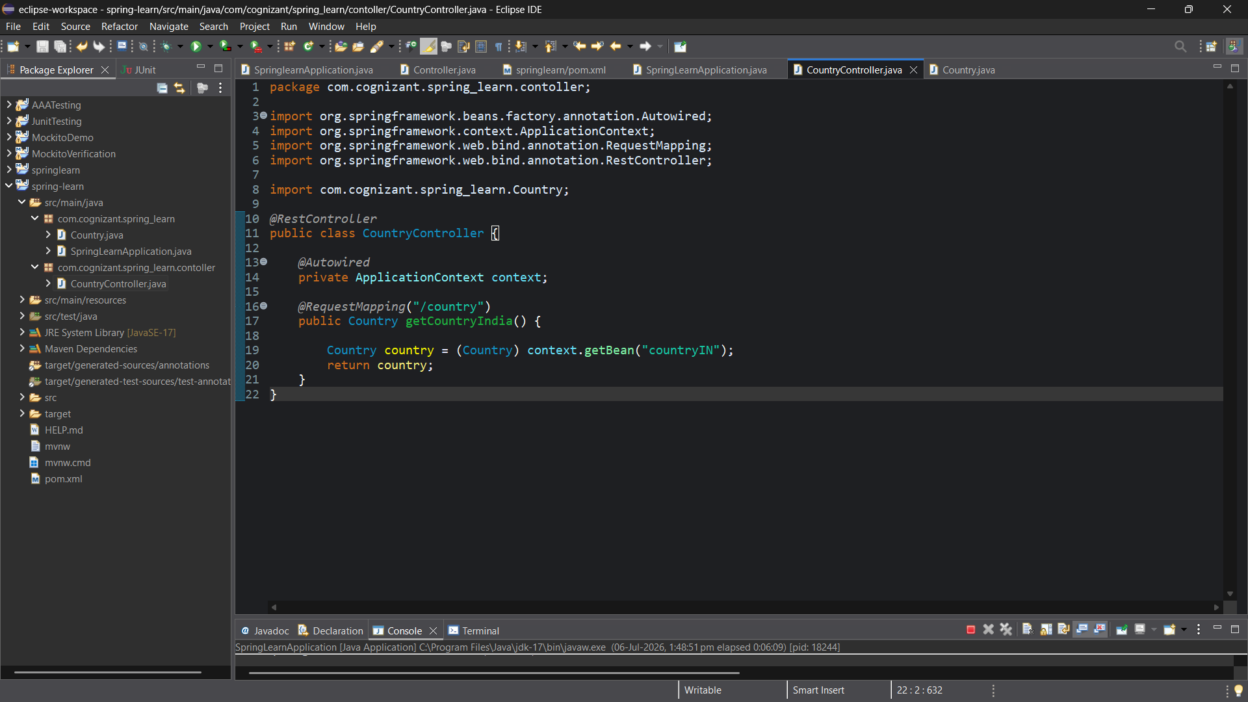
Country.java:
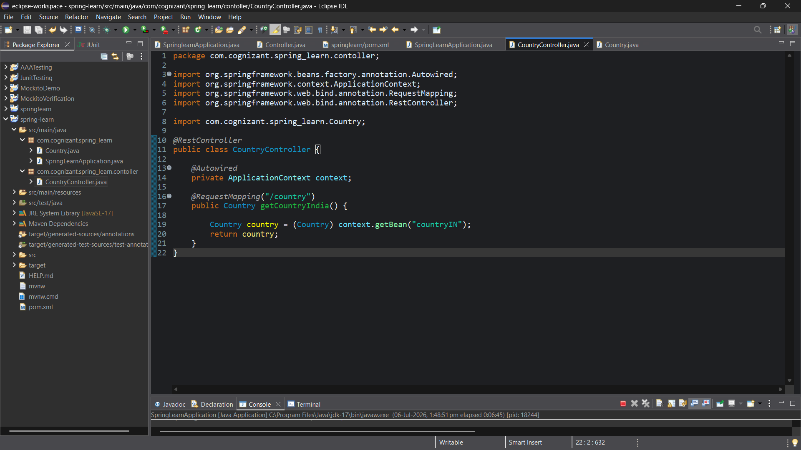

Output:
